Report for AS04

**FCFS:** First come first serve, whichever is first in the array will be dealt with first

**SSTF:** Shortest seek time first, track which are closer to current disk head position

**SCAN:** Goes in a particular direction and when it reaches the end of the disk, it goes in reverse direction

**CSCAN:** Goes in ascending order back down to the other end. It goes from one end to the other which is why it is seen as an elevator

**LOOK:** Similar to scan, but it goes from the last request to be served and reverses direction from there.

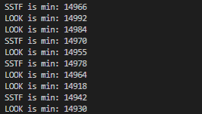

Above is the picture running my code 10 times while head pos is initialized at 5k

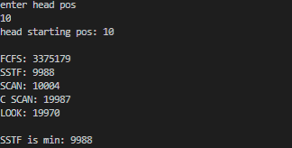

This is when head pos is initialized at 10

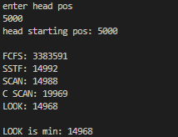  
This is when head pos is initialized at 5000

**Result:** Based on my findings, it seems that SSTF and LOOK are basically almost the same. SSTF performs equally as well as SCAN when the head pos starts lower and SSTF performs equally as well as SCAN and LOOK when head pos is higher. So the most efficient algorithm would be SSTF as its better overall